
Submitted by : Spogmai Jan
Roll no : 2430 -0081
Submitted to : sir nouman asim
DATE OF SUBMISSION : 29/12/2025

Computer networks lab 13
TASK 01:
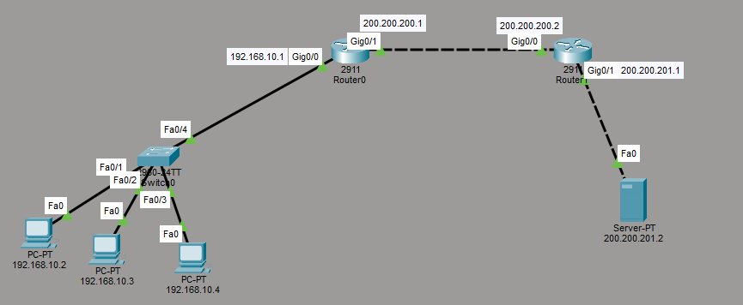
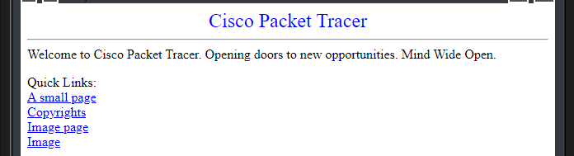

Task 2:
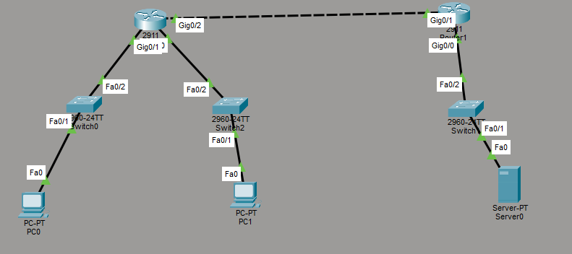
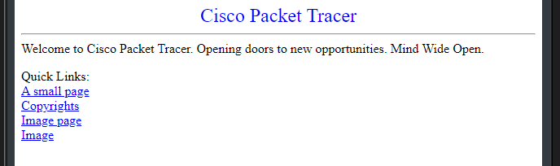

TASK 03:





